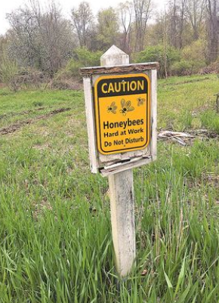
Bio: Brian Peterson is the Founder of Bees in the B. He is a 5th grade teacher, Adjunct Professor at Oakland University, and also the President of the Michigan Science Association.

Bees in the D: Founded in 2016, Bees in the D is a 501 (c) (3) non-profit organization whose mission is to create a cooperative effort between residents, schools, organizations, businesses in the city of Detroit and Southeast Michigan to contribute to both the health of pollinators and honey bee colonies and the education of their importance to our environment. They have introduced 6 million bees and managed over 100 bee hives at over 35 locations, across 5 counties, and in 2 countries. They introduce students of all ages to the importance of pollinators and the environment, while providing a hands-on learning experience inside the beehive.
Click here to learn more about the Bees in the D.
Figure 1: https://beesinthed.com/photo-gallery

